**Math round function**

The JavaScript math round method used to round the given number to the closest integer value and returns it.

**Syntax:** **Math.round(number);**

**If the given number is:**

|  |  |  |
| --- | --- | --- |
| **Input number** | **Example** | **Output number** |
| Nothing | Math.round(± integer number); | NaN |
| ± integer number | Math.round(± integer number); | ± integer number as it’s |
| + Floating number with floating part ≥ 0.5 | Math.round(± floating number]0.5:0.9]); | Input number without floating part + 1 |
| + Floating number with floating part < 0.5 | Math.round(± floating number[1:5[); | Input number without floating part. |
| - Floating number with floating part ≤ 0.5 | Math.round(± floating number[0.1:0.5[); | Input number without floating part. |
| - Floating number with floating part > 0.5 | Math.round(± floating number]0.5:0.9]); | Input number without floating part - 1 |

**Example:**

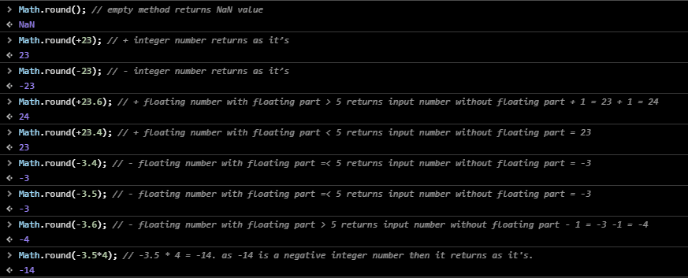

**Note:**

Codes executed from up to down and from most inner part to most outer part. See last method in the previous example.